Assignment

Exercise 6.1

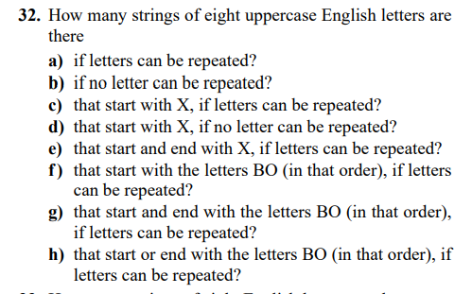

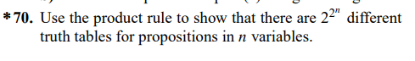

Exercise 6.2

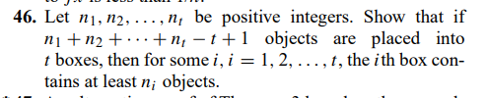

Exercise 8.1

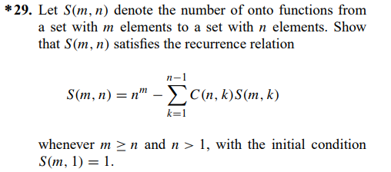

Exercise 8.2





Exercise 8.4

